Koneru Lakshmaiah Education Foundation
(Deemed to be University)

Course Code: 22SDEC14R
Course Name: Embedded Prototype
A Project Report
On
Project Title
CAN Bus Intrusion Detection System
SUBMITTED BY:
2300049051 - RUCHITH
2300049071 - M.PARDHSARDHI
230004907 - D.ABHIRAM
2300049088 - PRAVEEN
UNDER THE GUIDANCE OF
Dr Aswin Kumer S V
Associate Professor-ECE, HoD-EL&GE

Green fields, Vaddeswaram – 522 502
Guntur Dist., AP, India.

K L E F

DEPARTMENT OF ELECTRONICS AND COMMUNICATION ENGINEERING
(DST-FIST Sponsored Department)



DECLARATION

The CAN-IDS-System repository appears to implement an Intrusion Detection System (IDS) for Controller Area Network (CAN) bus in automotive contexts. It contains code and resources simulating or monitoring different Electronic Control Units (ECUs) and attacker nodes, along with demo files and supporting media.

K L E F

DEPARTMENT OF ELECTRONICS AND COMMUNICATION ENGINEERING
(DST-FIST Sponsored Department)


CERTIFICATE
This is to certify that the Project Report entitled is being submitted CAN Bus Intrusion Detection System using ESP32 by 2300049051 RUCHITH ,2300049071-M.PARDHSARDHI,2300049077-D.ABHIRAM,2300049088-PRAVEEN ,submitted in partial fulfilment for the award of B.Tech in Electronics and Communication Engineering to the K L University is a record of bonafide work carried out under our guidance and supervision.
The results embodied in this report have not been copied from any other departments/ University/Institute.
Signature of Supervisor
Signature of the HOD Signature of the External Examiner

ACKNOWLEDGMENT

It is great pleasure for me to express my gratitude to our honourable President Sri. Koneru Satyanarayana, for giving the opportunity and platform with facilities in accomplishing the project report.
I express the sincere gratitude to our Vice Chancellor, Dr G P S Varma for his administration towards our academic growth.
I express the sincere gratitude to our Pro VCs, Dr N Venkatram & Dr K Raja Sekara Rao for their administration towards our academic growth.
I record it as my privilege to deeply thank our principal, Dr.V. Rajesh for providing us the efficient faculty and facilities to make our ideas into reality.
I express sincere gratitude to our pioneer Dr I Govardhani, HOD-ECE for his leadership and constant motivation provided in successful completion of our academic semester.
I express my sincere thanks to our project mentors Dr Aswin Kumer S V, Associate Professor, ECE & HoD-EL&GE for their novel association of ideas, encouragement, appreciation, and intellectual zeal which motivated us to venture this project successfully.
Finally, it is pleased to acknowledge the indebtedness to all those who devoted themselves directly or indirectly to make this project report success.

ABSTRACT
The CAN-IDS-System project presents an Intrusion Detection System (IDS) designed to enhance the security of automotive Controller Area Network (CAN) buses. By simulating multiple Electronic Control Units (ECUs)—including brake and speed sensors—and a malicious attacker node, the system demonstrates real-time monitoring and detection of unauthorized or anomalous CAN messages. Implemented on Arduino-compatible hardware, the IDS analyzes CAN traffic patterns to identify potential cyber-attacks, safeguarding critical vehicle functions. This modular approach provides a practical framework for research and development of robust automotive cybersecurity solutions.Literature Survey
Key Functionalities:
Simulates multiple ECUs (Brake, Speed) sending CAN messages.
- Simulates an attacker node injecting malicious CAN frames.
- Monitors CAN traffic in real-time to detect intrusions.
- Alerts on abnormal or unauthorized CAN messages.
- Arduino-based modular design for embedded deployment.
- Includes demo media for system visualization.

INDEX
S.NO | TITLE
1 | Introduction
2 | Aim of the Project
3 | Proposed Methodology  (Include Block Diagram/Flow Chart)
4 | Components Explanation
5 | Implementation Methodology  (Circuit and Implementation)
6 | Results and Discussions  (With Screenshots)
7  8 | Source Code  Conclusion and Future Scope

- Introduction:
Modern vehicles rely heavily on the Controller Area Network (CAN) bus to enable communication between various Electronic Control Units (ECUs). However, the CAN protocol lacks built-in security features, making it vulnerable to cyber-attacks that can compromise vehicle safety. The CAN-IDS-System project aims to address these vulnerabilities by implementing an Intrusion Detection System (IDS) that monitors CAN traffic in real-time, detecting malicious activities and unauthorized messages. Using Arduino-based ECUs and attacker simulations, this system provides a practical framework for improving automotive cybersecurity through early threat detection.
- Problem Statement
The Controller Area Network (CAN) protocol, widely used in modern vehicles, lacks inherent security mechanisms, leaving automotive systems vulnerable to cyber-attacks. Malicious nodes can inject unauthorized messages into the CAN bus, potentially disrupting critical vehicle functions such as braking, acceleration, or speed control. Current vehicle architectures often do not provide real-time detection of such intrusions. The challenge is to design an efficient, real-time Intrusion Detection System (IDS) that can monitor CAN traffic, identify anomalous or malicious messages, and alert the system to prevent potential safety hazards.
3. Detailed System Architecture
- The CAN-IDS-System is designed as a modular, Arduino-based architecture that simulates a real vehicle CAN bus network. It consists of multiple functional nodes, each representing an Electronic Control Unit (ECU), along with an attacker node and a central Intrusion Detection System (IDS) monitor. The architecture ensures real-time communication, monitoring, and anomaly detection on the CAN bus.
Components
- ECUs (Electronic Control Units)
  - Brake ECU: Simulates brake-related CAN messages, representing the vehicle’s braking system.
  - Speed ECU: Simulates speed sensor messages, providing real-time speed data on the CAN bus.
  - Function: These ECUs generate normal operational traffic for the IDS to monitor.
- Attacker Node
  - Simulates a malicious entity injecting unauthorized or harmful CAN frames into the bus.
  - Purpose: Tests the IDS’s ability to detect abnormal or malicious activity.
- IDS Monitor
  - Central monitoring module that listens to all CAN traffic.
  - Analyzes message patterns and identifies anomalies using predefined rules or thresholds.
  - Triggers alerts when suspicious activity is detected.
- CAN Bus
  - The communication backbone connecting all ECUs and nodes.
  - Transmits data frames between nodes and the IDS monitor.
- User Interface / Visualization
  - Architecture diagram (ARCHITECTURE_IMAGE.png) and demonstration video (OUTPUT_VIDEO.mp4) provide insights into system operation and results.

Workflow
- ECUs generate normal CAN traffic.
- Attacker node injects malicious messages at intervals.
- IDS Monitor continuously analyzes CAN frames in real-time.
- Suspicious messages are detected and logged/alerted.
- System provides feedback through visualization or output logs.

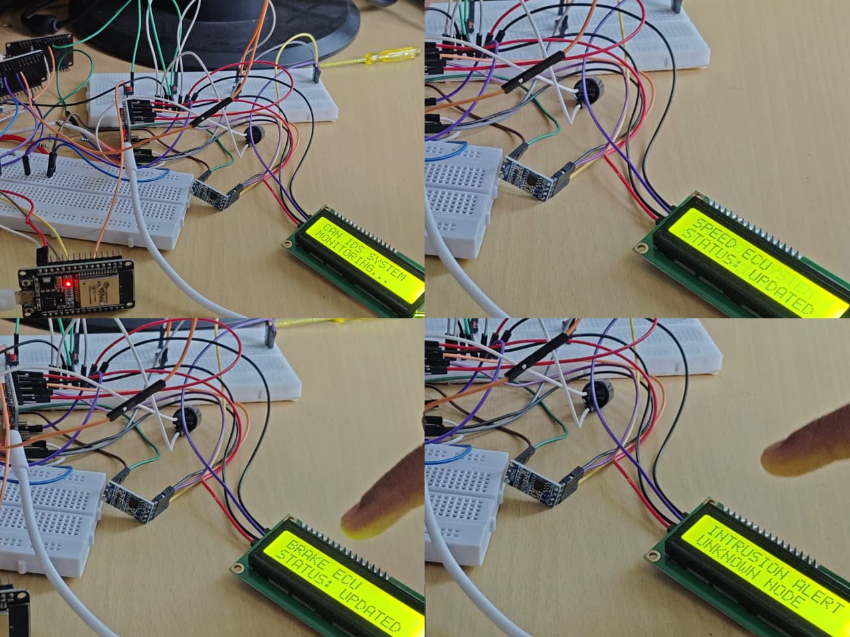

5. Comprehensive Working Methodology
Working Methodology
- Setup: Arduino-based ECUs and attacker node connected via CAN bus.
- Normal Traffic: Brake and Speed ECUs generate legitimate CAN messages.
- Attack Simulation: Attacker node injects malicious or spoofed messages.
- Real-Time Monitoring: IDS Monitor continuously reads and analyzes CAN traffic.
- Intrusion Detection: Abnormal or unauthorized messages are detected and logged.
- Visualization: Logs, diagrams, and demo videos show system operation.
- Modular Testing: System can be extended with more ECUs or attack scenarios for evaluation.
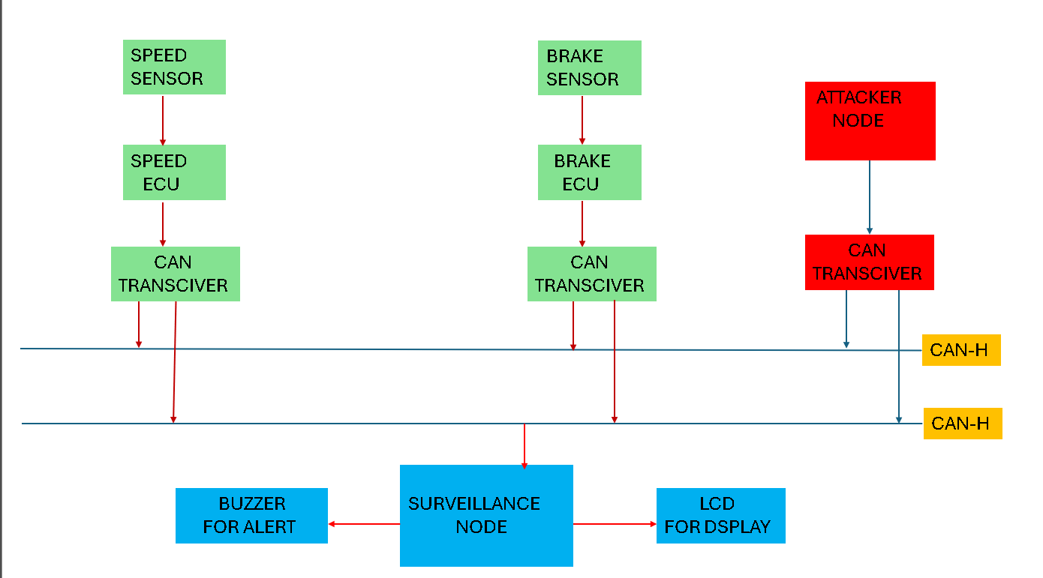
6. Expanded Applications and Use Cases
Applications and Use Cases
- Automotive Cybersecurity: Detects attacks on CAN bus in real-time.
- Research & Testing: Simulates attacks to evaluate IDS performance.
- Education & Training: Demonstrates vehicle network security concepts.
- Industrial Prototyping: Tests ECUs safely before deployment.
- Connected Vehicles: Can extend to secure V2V and V2I communications.
7. Future Scope and Enhancements
- • Advanced Detection Algorithms: Integrate machine learning for more accurate anomaly detection.
- • Multiple ECU Integration: Expand to include more vehicle systems like engine, infotainment, and airbags.
- • Real Vehicle Deployment: Test the IDS on real cars for practical validation.
- • Cloud & IoT Connectivity: Enable remote monitoring and analysis for connected vehicles.
- • Alert & Response Automation: Automatically block or mitigate detected attacks.
- • User Interface Improvements: Add dashboards for real-time visualization of CAN traffic and alerts.

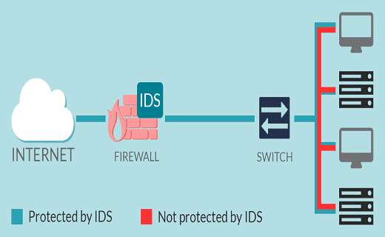
8. Conclusion
The CAN-IDS-System successfully demonstrates real-time intrusion detection on a simulated vehicle CAN bus. By monitoring traffic from multiple ECUs and detecting malicious activity from an attacker node, the system enhances vehicle cybersecurity and provides a practical framework for research, testing, and education. Its modular design allows easy expansion, making it a valuable tool for developing safer and more secure automotive systems.

